RVPlasticParts

Rudder Pedal Extensions Installation Instructions

Weight: 74 grams for pilot side installation
Step 1: Remove all nuts and bolts
Step2: Observe the anti-skid tape on the inside (3 inch x .5 inch) and its position. It is placed at the opposite end of the anti-rotation feature end.

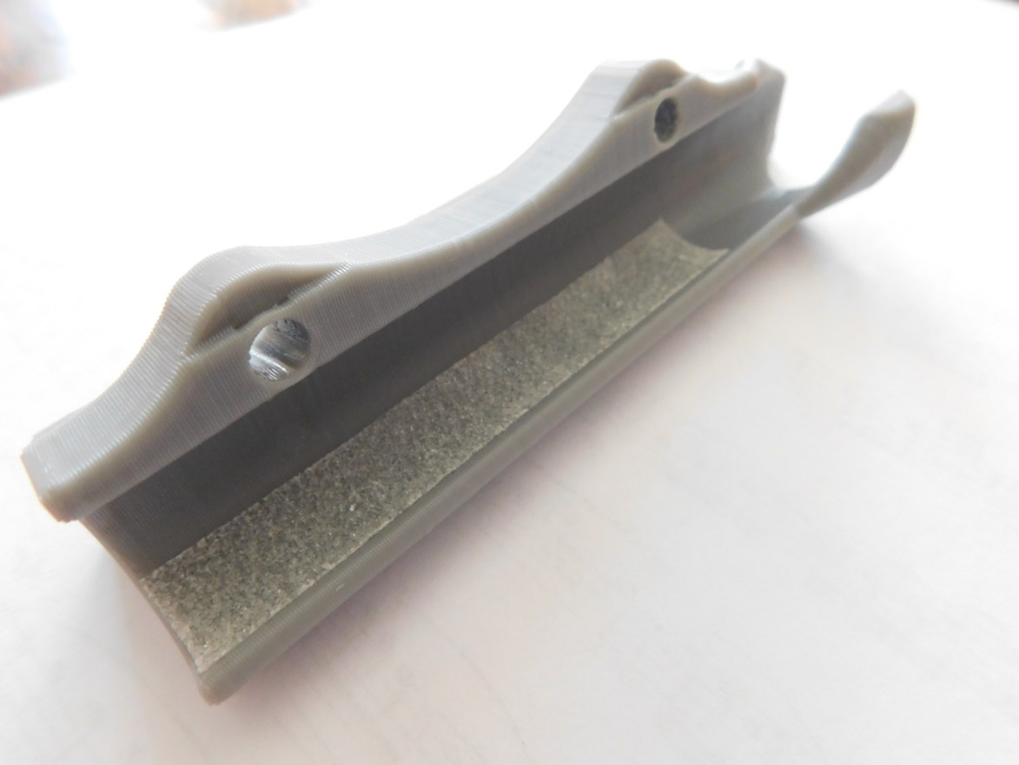

Step3: If desired, a small strip of anti-skid tape may be added to the flat surface (for flat style extensions) for added foot grip. Additional tape is included for this.
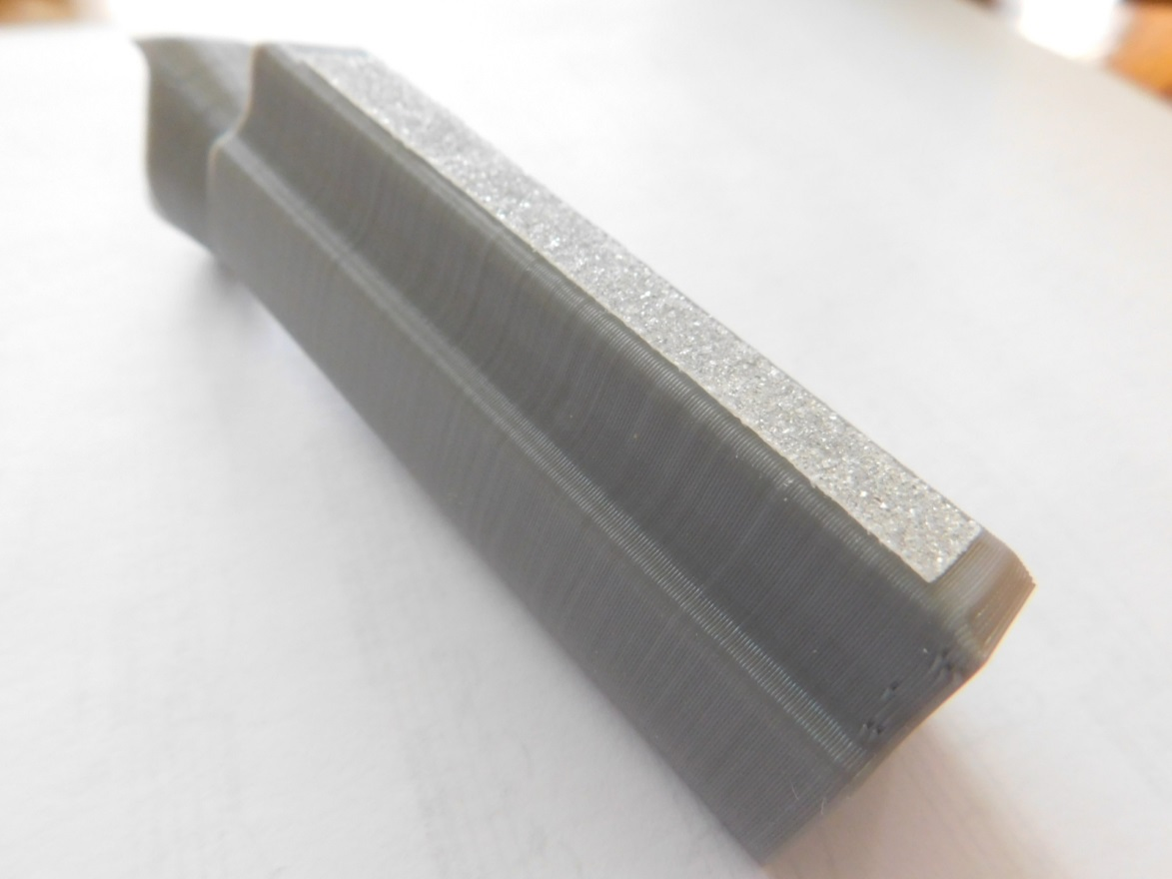

Step4: To ease installation, snap the extension end onto the horizontal bar at angle where the anti-skid tape is not present and slide the extension sideways to engage the vertical bar with the anti-rotation feature. Then press the extension fully onto the bar.
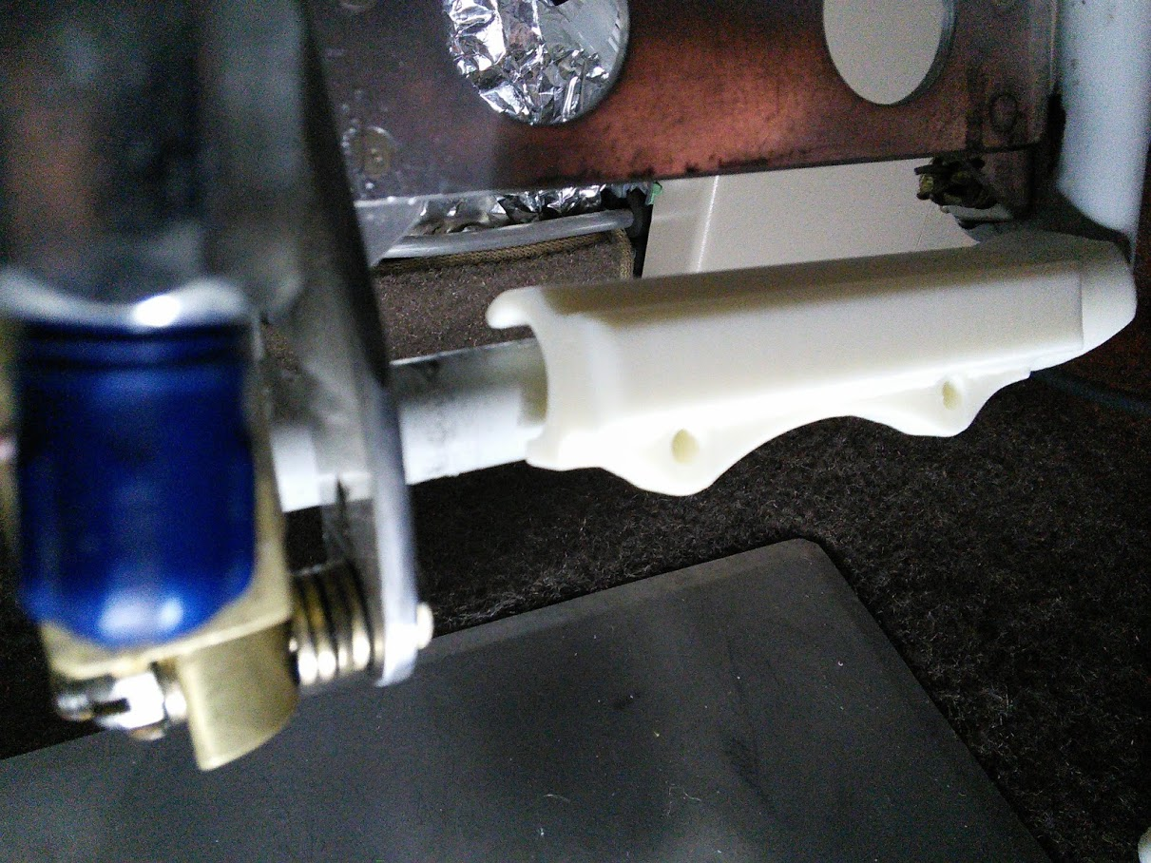

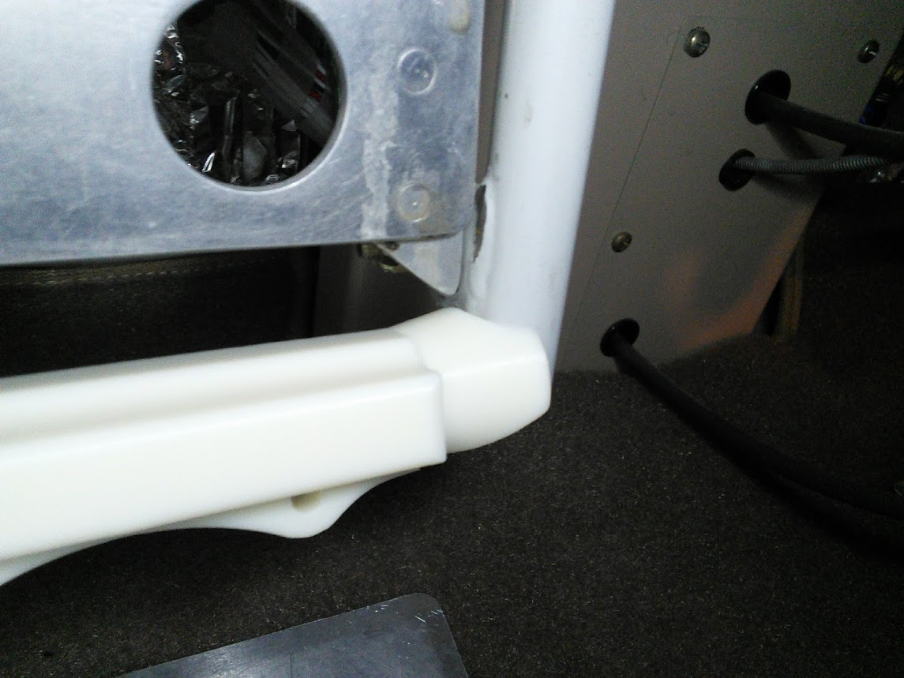

Step 5: Install nuts to the clamp pieces and install bolts. Tighten to snug and then reverse torque a small amount to orient clamps vertically. A piece of tape can be used to temporarily position the clamp piece to ease installation.
